1. Summary
This project develops a Restaurant Order Management System that supports both dine-in and takeout services. The system manages customers, employees, tables, menu items, orders, and payments. The database is designed using relational modeling principles and is normalized to Third Normal Form (3NF) to ensure data consistency and reduce redundancy.

2. Introduction
Restaurants need an efficient system to handle orders, especially when managing both dine-in and takeout services at the same time. This project provides a database solution that organizes all restaurant operations, including menu management, order processing, and payment tracking.
The system is designed to reflect a real-world restaurant scenario, including menu updates, customer diversity, and different types of orders.

3. Data Modeling
The system is built around several key entities:
- Customers: stores customer information
- Employees: stores staff information
- Dining Tables: manages table availability
- Menu Categories and Menu Items: organizes food and drinks
- Orders: central table connecting customers, employees, and tables
- Order Items: stores items within each order
- Takeout Orders: stores pickup details
- Payments: records transactions
The Orders table is the central entity, linking multiple tables together through foreign keys.
Relationships include:
- One customer can have many orders
- One employee can handle many orders
- One order can have multiple items
- One order may have one takeout record
- One order can have payment records

4. ER Diagram
The ER diagram illustrates all entities, primary keys, foreign keys, and relationships in the system.
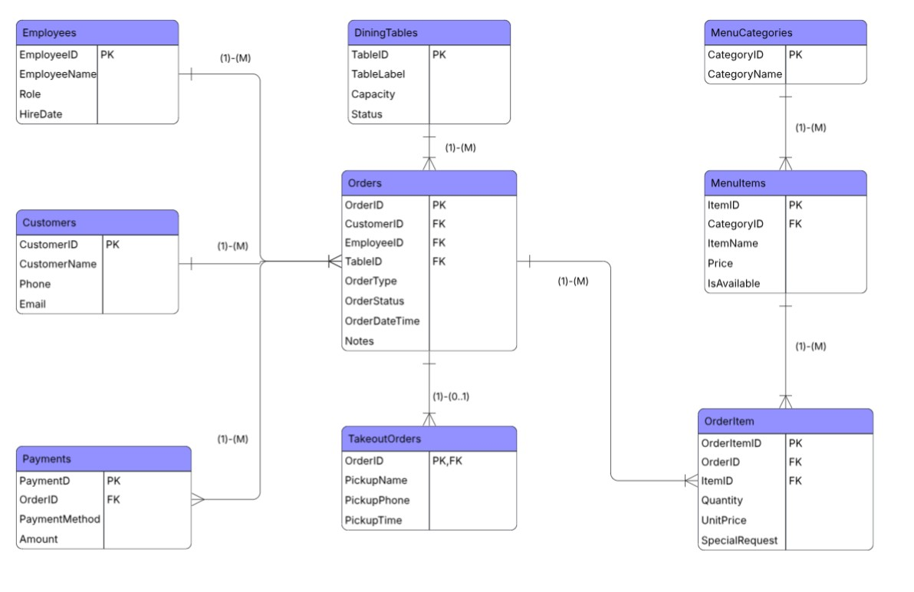

Explanation:
The ER diagram shows how the Orders table connects customers, employees, and menu items. The OrderItems table resolves the many-to-many relationship between orders and menu items. The TakeoutOrders table is separated to store pickup-specific information only when needed.

5. Design Decisions
Several important design decisions were made:
- Separation of Takeout Orders
Takeout-specific data is stored in a separate table to avoid null values in the Orders table.
- OrderItems Table
A bridge table is used to handle the many-to-many relationship between orders and menu items.
- Menu Structure
Menu categories and items are separated to improve organization and avoid repetition.
- Use of Prefix (REST_)
All table names use a prefix to avoid conflicts with existing tables in the database.

6. Normalization (3NF)
This database is in 3NF because each table focuses on one type of data and has its own primary key. All non-key attributes depend only on that key. Repeated data is avoided by separating menu categories, takeout details, and order items into different tables. There are no unnecessary dependencies, since information is not duplicated across tables.

7. SQL Implementation
The project includes several SQL components:
Schema
- Tables are created using CREATE TABLE
- Primary keys and foreign keys are defined
- Constraints such as CHECK and UNIQUE are applied
Sample Data
- Data reflects a Basque-style restaurant
- Employee names include both Spanish and English styles
- Customers include a mix of different backgrounds
Reset Script
- A reset.sql file is used to safely drop all tables
- This allows the database to be rebuilt easily

8. Advanced Features
Additional SQL features were implemented:
ALTER TABLE
The schema was updated using ALTER TABLE to add new attributes, default values, and constraints. This demonstrates how the database can evolve.
MERGE Statement
The MERGE statement was used to update or insert customer information efficiently. This shows how data synchronization can be handled in a single query.
Reporting Queries
Additional queries were created to analyze business performance, including:
- Evening revenue
- Revenue over a period of time
- Most popular dishes
These queries help simulate real-world restaurant analytics.

9. Conclusion
This project demonstrates a complete database system for restaurant order management. It supports both dine-in and takeout operations, uses normalized design, and includes advanced SQL features such as MERGE and ALTER TABLE.
The system can be extended in the future to include features such as reservations, delivery services, or customer loyalty programs.

